**unsupervised learning:Clustering in Machine Learning**

Clustering is a type of unsupervised learning in machine learning where the goal is to group similar data points together based on their features. It helps in discovering inherent structures in data without prior labels. Common clustering algorithms include:

* **K-Means Clustering:** Partitions data into K distinct clusters based on distance to the centroid of each cluster.
* **Hierarchical Clustering:** Builds a tree of clusters by either merging or splitting existing clusters.
* DBSCAN (Density-Based Spatial Clustering of Applications with Noise): Groups together points that are closely packed together while marking points in low-density regions as outliers.
* Gaussian Mixture Models (GMM): Assumes that the data is generated from a mixture of several Gaussian distributions.

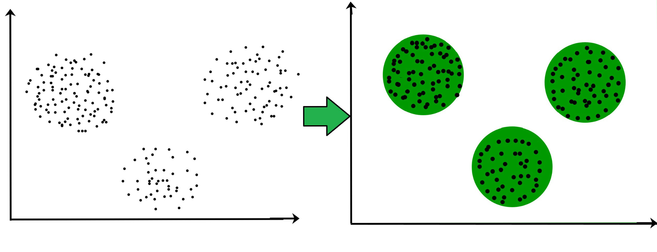

**Types of Clustering**

**Hard clustering:**

Hard clustering is a type of clustering where each data point is assigned to exactly one cluster. This means that a data point either belongs to a cluster or it does not, with no overlap between clusters. The most common example of hard clustering is K-Means clustering.

**Example: K-Means Clustering**

Let's demonstrate K-Means clustering using a synthetic dataset. We'll generate some random data points and then apply K-Means to cluster them into a specified number of clusters.

**Soft clustering:**

Soft clustering, also known as fuzzy clustering, allows data points to belong to multiple clusters with varying degrees of membership. This contrasts with hard clustering, where each data point belongs to exactly one cluster. A common example of soft clustering is the Fuzzy C-Means (FCM) algorithm.

Example: Fuzzy C-Means Clustering

In this example, I'll demonstrate how to apply Fuzzy C-Means clustering to a synthetic dataset. The algorithm will assign membership values to each data point for each cluster, indicating the degree of belonging.

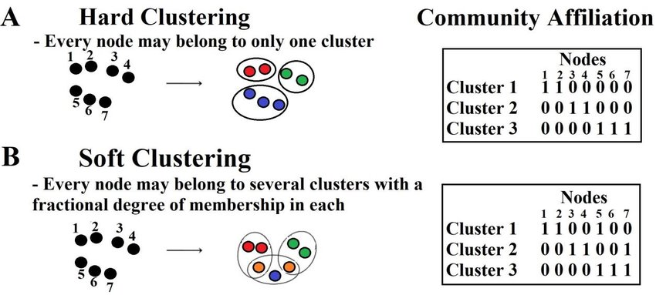

**Types of Clustering Algorithms**

* Centroid-based Clustering (Partitioning methods)
  + Centroid-based clustering, particularly in the context of partitioning methods, focuses on grouping data points into clusters based on their proximity to a central point (the centroid) eg: K-Means Clustering
* Density-based Clustering (Model-based methods)
  + Density-based clustering, particularly in the context of model-based methods, focuses on identifying clusters based on the density of data points in a given region. Eg: DBSCAN
* Connectivity-based Clustering (Hierarchical clustering)
  + Connectivity-based clustering, specifically in the context of hierarchical clustering, organizes data points into a tree-like structure (dendrogram) based on their connectivity or distance.

# Load necessary libraries

library(ggplot2)

library(dplyr)

library(cluster)

# Load the Iris dataset

data(iris)

# Perform hierarchical clustering

hc <- hclust(dist(iris[, -5]), method = "ward.D2") # Exclude the species column

# Plot the dendrogram

plot(hc, labels = iris$Species, main = "Hierarchical Clustering Dendrogram", xlab = "Species", ylab = "Distance")

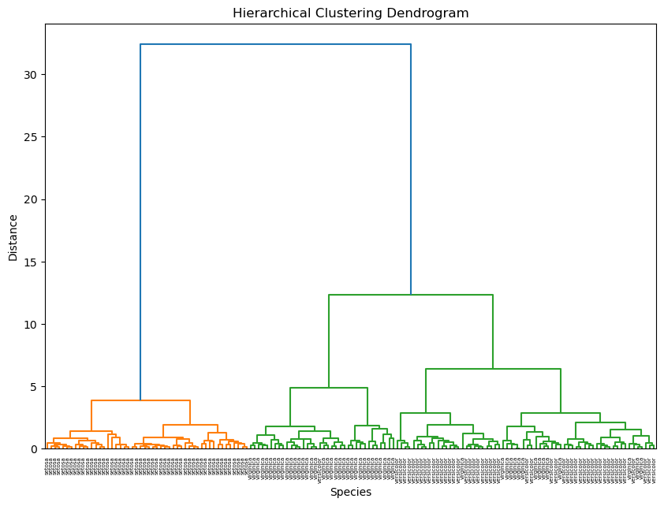

* Distribution-based Clustering
  + Distribution-based clustering is a method that assumes the data points are generated from a mixture of underlying probability distributions.